Statistics for the Social Sciences
Assignment 4.4

What percentage of variance in income is explained by knowing a person’s level of educational attainment? We’ll answer that question using a scatterplot in Excel. We’ll be using data taken from a Bureau of Labor Statistics chart. The chart looks like this:

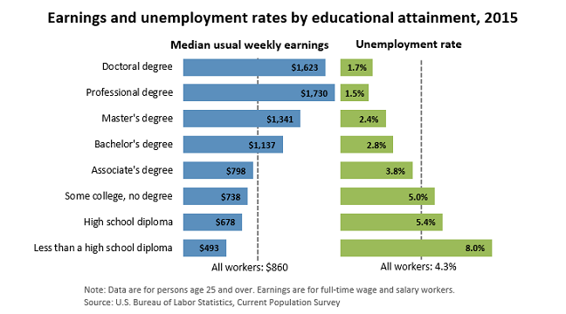

You’ll need to translate that data into a spreadsheet. The columns will look something like this:

Education | Earnings | Unemployment Rate
1 | 493 | 8
2 | 678 | 5.4
3 | 738 | 5
4 | 798 | 3.8
5 | 1137 | 2.8
6 | 1341 | 2.4
7 | 1730 | 1.5
8 | 1623 | 1.7
Education Legend
Less than High school |  | 1
High School Diploma |  | 2
Some College |  | 3
Associate's |  | 4
Bachelor's |  | 5
Master's |  | 6
Professional |  | 7
Doctoral |  | 8

Note that I’ve converted (coded) the education level into numbers so we can use it to create a trendline. Here are the steps you should take:

- Build and excel file using the data provided above.
- Highlight the Education and Earnings columns.
- Insert a basic scatterplot using the same steps you used for assignment 4.3.
- Right click over the data points and select Add Trendline.
- Select the “display equation on chart” option.
- Select the “Display R-squared value on chart” option.
- Use the border tool to “pretty up” your chart.
- Save your file as YourLastName_Your_First_Name_4.4.
- Submit your Excel file via Blackboard.

The value for R2 that appears on the plot can be interpreted as the percentage of variance explained in income by knowing educational level.

Your finished file should look like this:

